SUPPORTING SICK CHILDREN
This annual fundraiser, hosted by the Miranda Foundation, aims to raise funds and awareness of the integral and life changing work Monash Children’s Hospital does for families and our community.
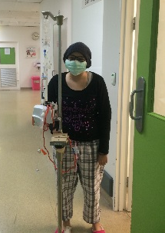
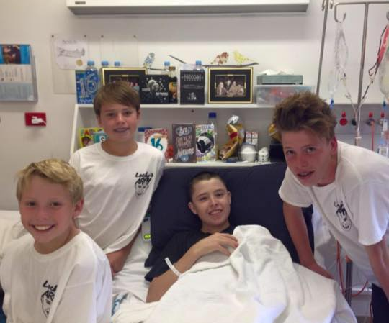
Australia’s Biggest Playdate is back and bigger than ever in 2019, for its fourth consecutive year. As a valued member of our community we would love to have your involvement.

Our fun-filled event will feature rides, games, balloons, face painting, market stalls, a silent auction, delicious food and a range of children’s favourite characters; all for gold coin donations.
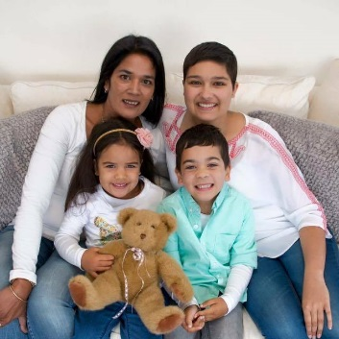
Join us in living our mission of being
‘In It Together’.
Sunday 7th April 11am-3pm
Aspendale Gardens Community Centre,
Aspendale Gardens

Our event is a success because of your contribution & we would really appreciate your SUPPORT to raise funds for our hospital. (please see other side)
Please call Vanessa Miranda on 0402 407 990 or email vanessa@mirandas.com.au confirm your commitment. We look forward to working with you this year.

HOW YOU CAN BE INVOLVED …

*SPONSORSHIP
We need your sponsorship to pay for the cost of the attractions and associated costs. All entrance fees, and purchases on the day will then go directly to our benefit the new children’s hospital, specifically to the children’s cancer center.

You can help by being a gold $1000, silver $500 or bronze $250 sponsor. Please fill out our donation form.

*DONATION
You can help by donating a gift voucher or silent auction hamper or item/product.

*SPREAD THE WORD!
You can help by liking our Facebook page – The Miranda Foundation and marking your interest on our event page – The Biggest Playdate 2019. You can invite all your friends to our event, and share the event page to your social media.

You can display our event flyer at your location to help promote the event to our community.

